CSE 105: Structured Programming

Section: 7, Spring-2018

A Project Report

On

**Spell Checker**

Submitted By:

Group: 1

Group Members:

Syem Shibly Ador 2018-1-68-023

Md Ferdous 2018-1-60-098

Md Sadat Hossain 2018-1-60-096

Submitted To:

Amit Kumar Das

Lecturer, Dept. of CSE

Date of Submission: 07.04.2018

DEPARTMENT OF COMPUTER SCIENCE & ENGINEERING

EAST WEST UNIVERSITY

1. **Problem Statement**

A spell checker program is a type of program which we are going to check whether the spelling is spelled correctly or not. For example, if we input the word **“cat”** it will show that the spelling is spelled correctly but if we make a mistake and type **“kat”** then it will show that the spelling is spelled incorrectly and will suggest corrected word.

1. **System Requirements**

The system on which the project is implemented has the following properties:

Processor: Intel Core i3, 3.30 GHz

RAM: 8.00 GB

Operating System: Windows 10

IDE (Integrated Development Environment): Code-blocks

1. **System Design**

In this section, the algorithm of the project is described as below:

1. Input a String

2. Enter words in array.

3. Then press # to break function.

4. Then we enter the outputs

5. If min > cnt then , we print the input as output.

6. Display

7. “

8. Input word:

9. ”

10. If min == cnt , we print dictionary array.

11. Display

12. “

13. Suggested words:

14.”

1. **Implementation**

In this section, important parts of the source code are explained.

**TAKING INPUT:**

flag=1; //SIGNALS

Len=strlen(word) //counting word limit

for(i=0; i<dictionarycount; i++) //INFINITE LOOP

if(strcmp(word, "#")==0) //compare the input with string “#”

break; //if input is #, loop is terminated.

1. **Testing Results**

In this section, some sample input-outputs are explained with appropriate screenshot:

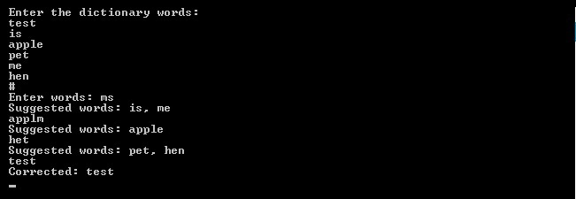

First we entered some words in the dictionary, for example: **test, is, apple, pet, me, hen**. Then according to our program, **“#”** stops the input of dictionary. Then we entered the words that we wanted to check. If the spelling is correct then it displays **“Corrected: (correct word)”**. If is it wrong, then is displays suggested words, for example: if we input **“ms”** then is shows that the spelling is wrong and it suggests two words which are **“is”** and **“me”.**

1. **The Future Scope**

* There are some limitations to our projects. The first limitation is that In our program if we input a word with uppercase letter or lowercase letter then we have to use the same way for checking the spelling otherwise it will show that our spelling is incorrect. The second limitation is that Our program only suitable for checking few words. The third and last limitation is Its can check one word at one time. In future, some modifications can be done to our program so that our program does not have any limitations.